13.94: a) From the parellel axis theorem, the moment of inertia about the pivot point is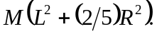

Using this in Eq. (13.39), With 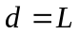 gives.

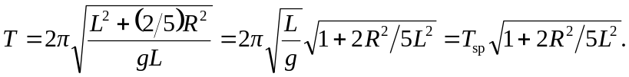

b) Letting 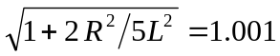and solving for the ratio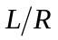 (or approximating the square root as 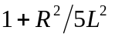) gives 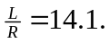
c)